**PROPOSAL**

**FOR**

**SUPPLY, INSTALLATION AND TRAINING OF**

**SAVANNA LMS SYSTEM.**

**Submitted by: TECHSAVANNA CO LTD**

Reliance Centre, 2nd Floor, Woodvale Grove, Westlands

Blessed Hse, Thika Road

P.O. Box 10306- 00100, Nairobi, KENYA.

[www.techsavanna.technology](http://www.techsavanna.technology)

**Contact Person:** FRED NJUGUNA/JACOB SHAVIA

Telephone: +254 722 537 792/+254 722 585 375

Email: [cto@techsavanna.technology](mailto:cto@techsavanna.technology)

**Date: 7 January 2020**

# Summary notes

### To guide you in the financial proposal, please find some notes

1. TECHSAVANNA COMPANY LTD will have the following teams on this project:
   1. 2 Technical Consultants
   2. 1 Project Manager

*(****The 3 staff will be involved in the project at different times****)*

1. TECHSAVANNA’S COMPANY LTD standard costs include:
   1. TECHSAVANNA COMPANY LTD uses 16% as the VAT rate where necessary

**Assumption:**

1. All future implementations will be charged separately at the rate of KES 2500 per day per consultant. All standard costs will apply during these rollouts and RCTI will meet them.
2. The software will NOT have any user license restrictions
3. The system will NOT have any server/ server license restrictions.
4. Future implementations charges to be agreed upon

### ANNEX B1

### SUMMARY OF COSTS

|  |  |
| --- | --- |
| Costs | Total in (KES) |
| |  | | --- | | Implementation and Consultancy fees 1-1000 clients | |  |
| Implementation and Consultancy fees 1000-10000 clients |  |
| |  | | --- | | Implementation and Consultancy fees 11000-50000 clients | |  |
| Training and Misc (10 days) |  |
| Monthly Recurrent for Hosting (10,000 clients and below) |  |
| Total cost KES |

**FEATURES OF MFS APPLICATION:**

1. MOBILE REGISTRATION MANAGEMENT

* Membership registration
* Loan applications
* Group guarantor ship
* Loan disbursements Via Mpesa

**CORE APPLICATION/BACK END APPLICATION**

* Members/Clients Database
  + Registration Fees
  + Personal Details (Address, Photo, Tel. Numbers etc.
  + Membership Details
  + Employment and Group Details
  + Next of Kin and Beneficiaries
* Loans Processing and Tracking
  + Interest Calculation Procedures
  + Rules for who qualifies for the loan
  + Share to Loan Ratio
  + Share to Income Ratio
  + Other charges associated with the loan
  + Guarantors and/or members in groups.
  + Printable Loan Schedule
  + Loan appraisal, approval and disbursements
* Savings and Current Accounts
  + Minimum Amount/savings in shares
  + Unlimited number of savings accounts
  + Cash Withdrawal and Share Transfers
* Cash Desk
  + Teller GL Accounts
  + Daily Activity report for cash movement tracking
* Guarantor capture and Group Maintenance
  + Auto-release of guarantor free shares upon loan repayment
  + Allow groups
* General Ledger Transactions
  + Inter-ledger transactions
  + GL to member accounts e.g. for salary transfers
  + GL to loan accounts
  + Bills and Income capture
* Journal Posting
  + Non-member related transactions e.g. petty cash, electricity bills, office stationery etc.
* Dividends calculation and Management
* User access levels and rights
  + Levels of Read-only, Read and Write and Read, Write and Update
  + Transaction Supervision
  + Audit Trail Reports
* Integration to 3rd party applications
  + Payroll
  + MPESA pay-bill
  + SMS Alerts(bulk sms)
  + Export to Excel, Word and PDF
  + Integration with visa cards pay pals etc

Standard MFS REPORTS which includes but not limited to

* + Final Accounts Reports
    - Income and Expenditure
    - Trial Balance
    - Balance Sheet
  + Loan Reports
    - Outstanding Loans
    - Loan Aging Analysis
    - Total Loans Reports
  + Member Statements

## Bulk SMS Solution

We have two options to bulk SMS solution:

* + SIM-Card based – mostly used whenever the sender expects a reply from the recipient.
  + Internet based – This is where we load SMS to the client who intends to send messages across different groups.
  + **Mobile USSD and ANDROID client applications**

**AMONG OUR CLIENTELE:**

**KCB,Waumini MFS,City Corporation MFS,Century MFS,Meru County MFS,UIP Credit etc**

**SAMPLE SCREENSHOTS:**

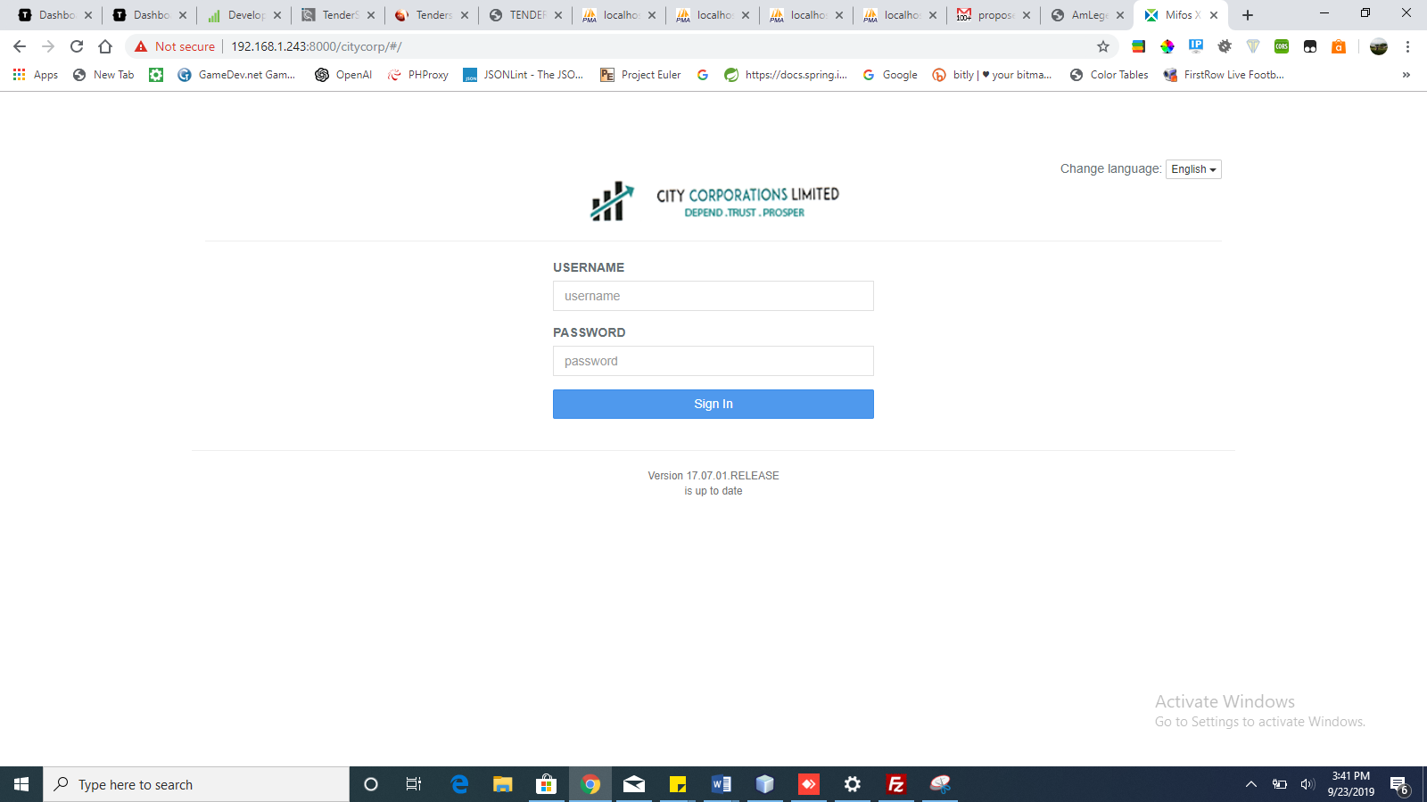

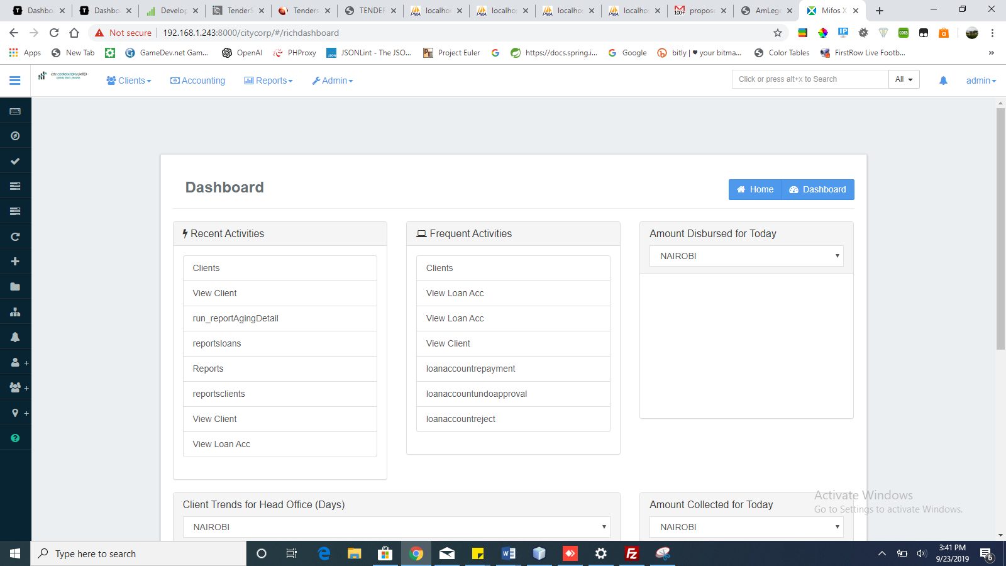

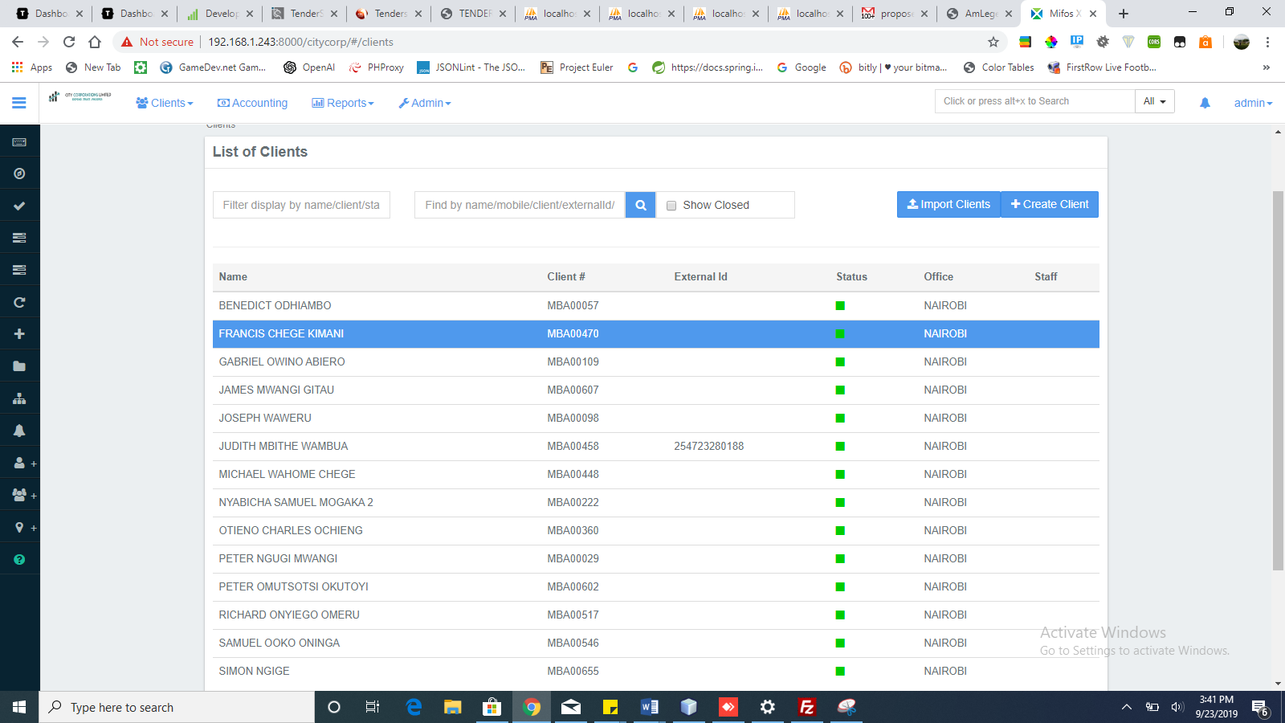

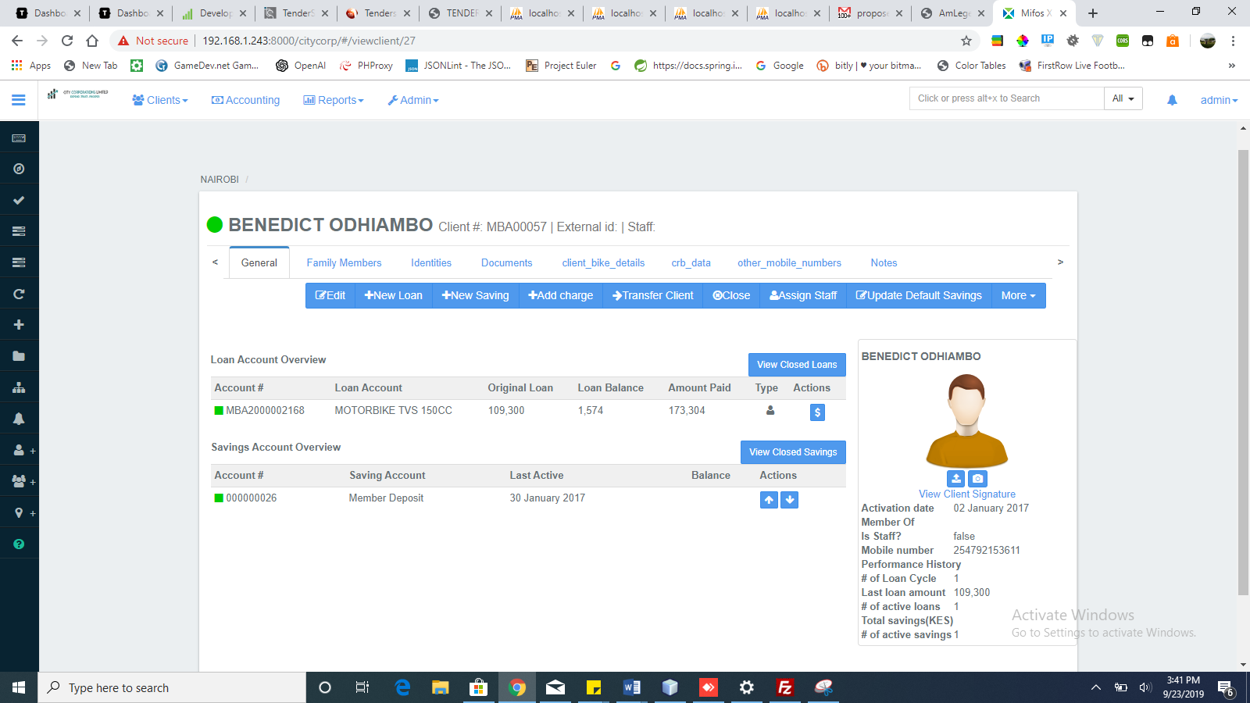

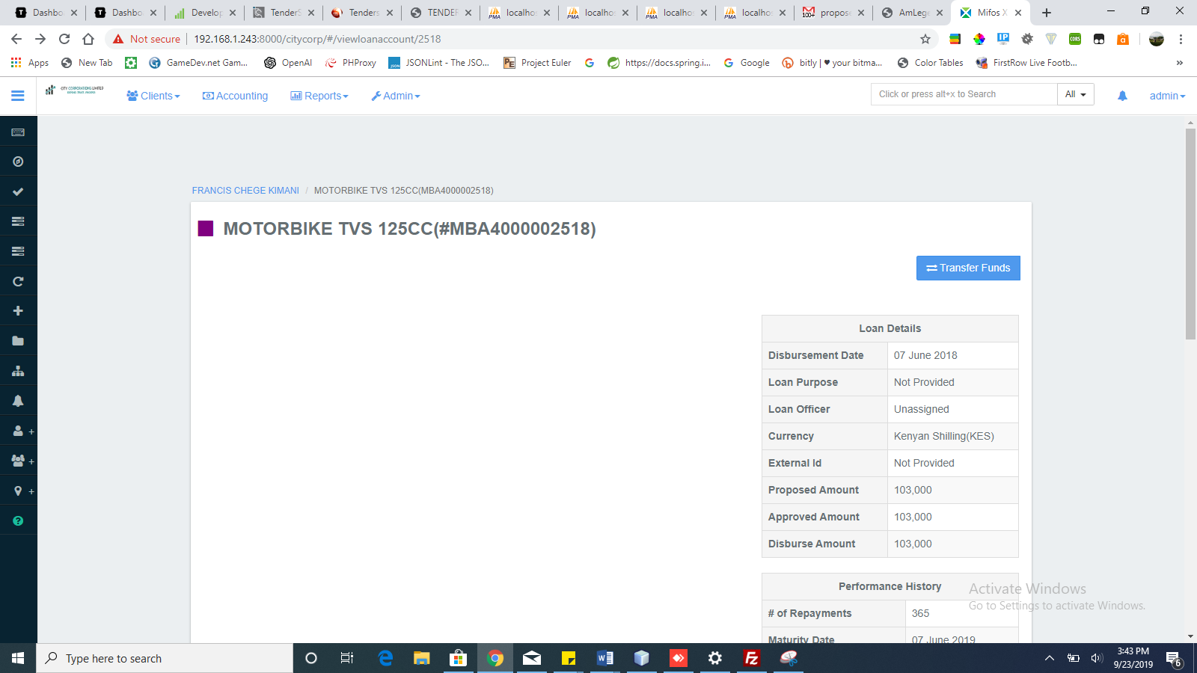

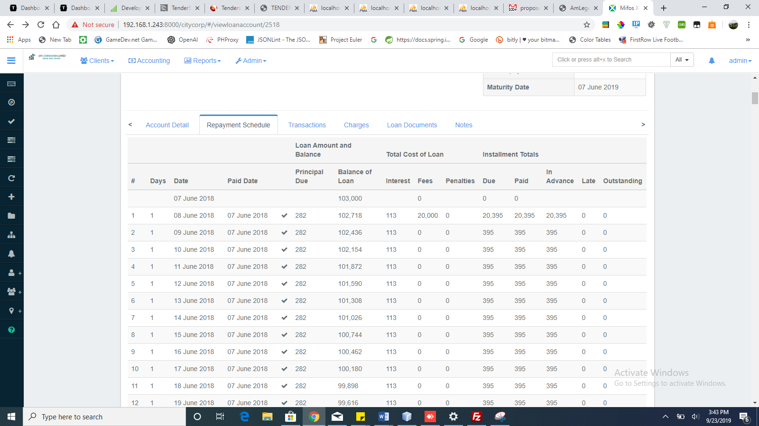

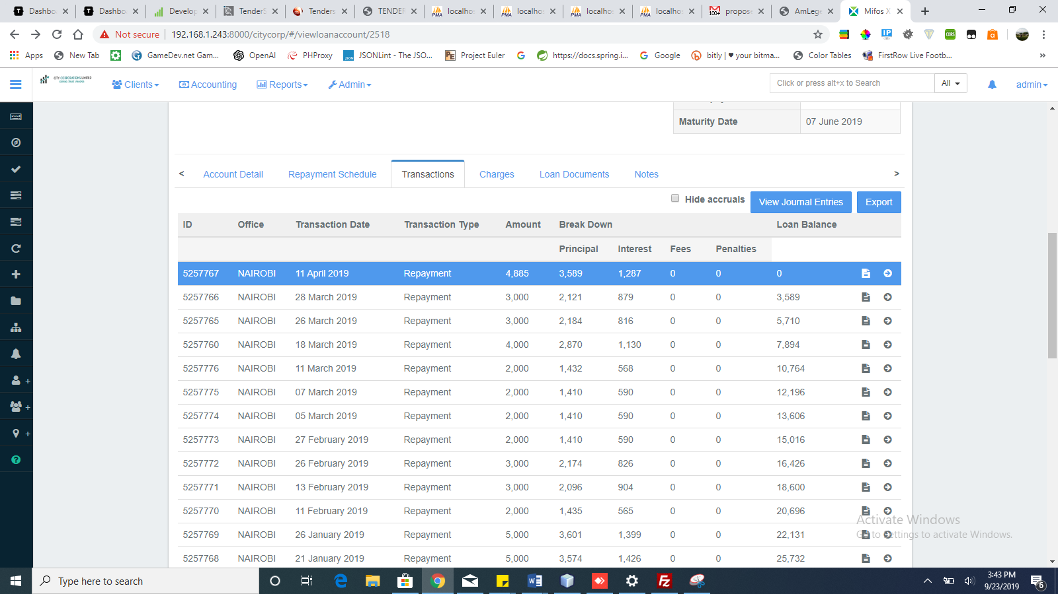

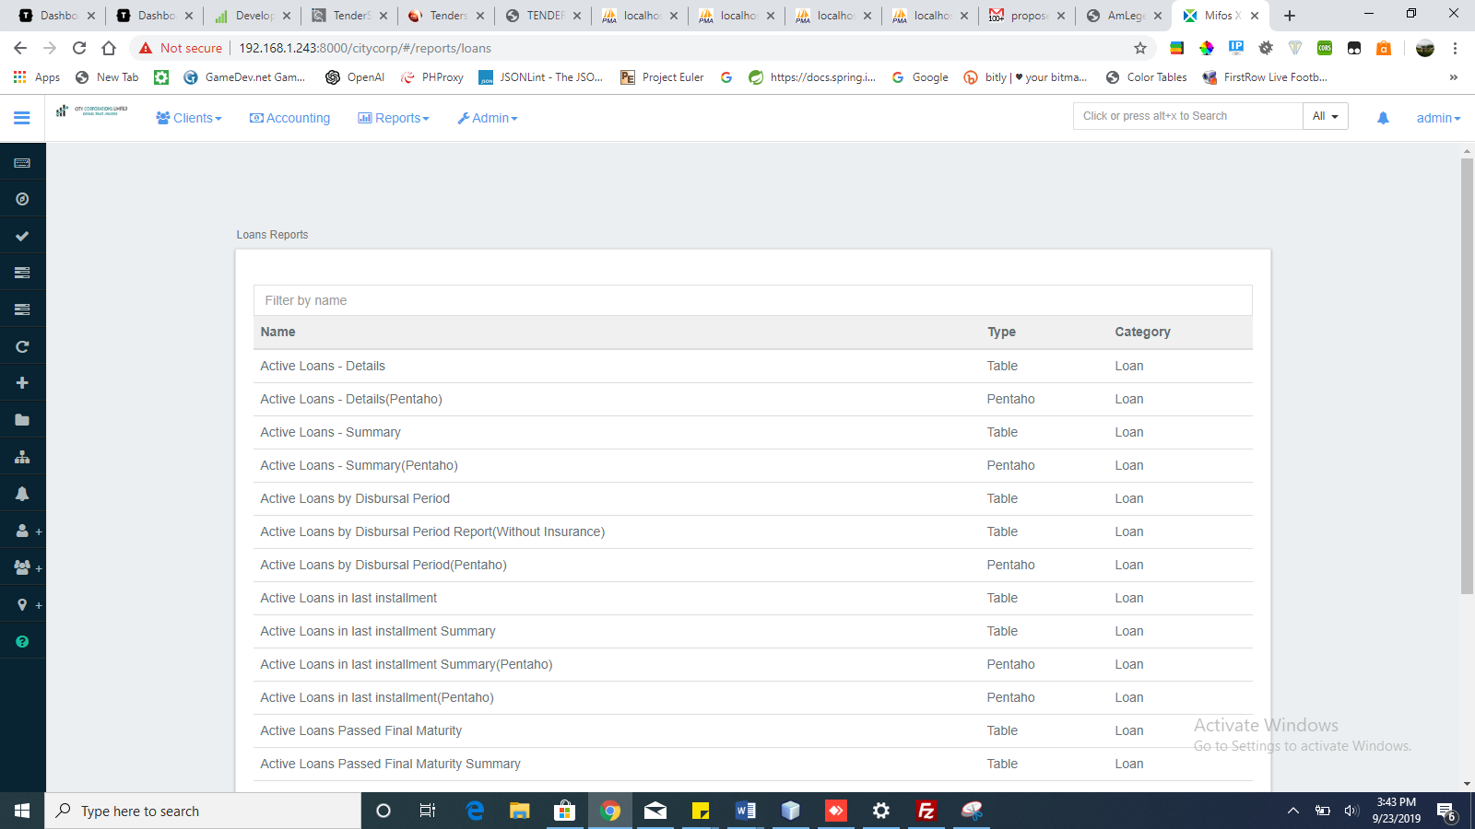

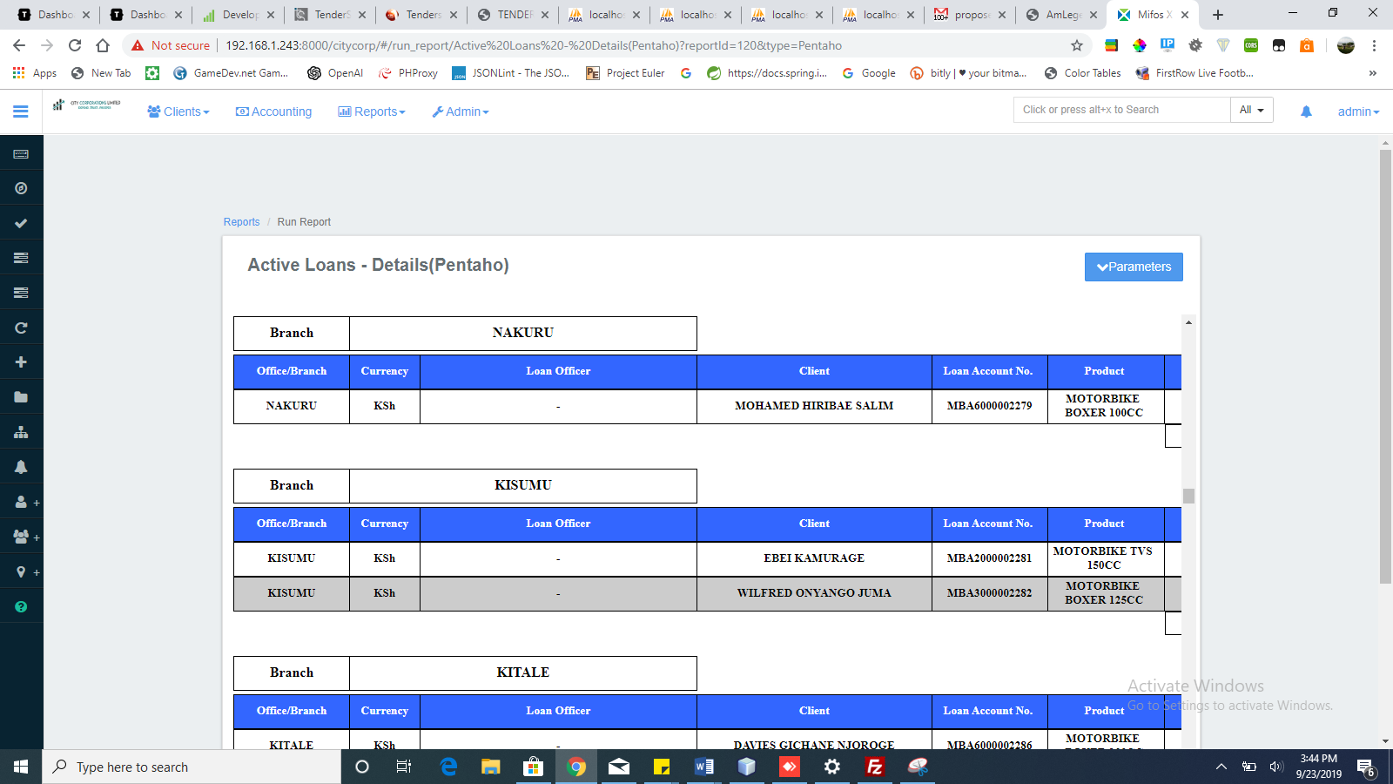

**WORKPLAN**

|  |  |  |  |  |
| --- | --- | --- | --- | --- |
| **Activity** | **Week 1** | **Week2** | **Week3** | **Week 4/5** |
| **Rollout** | **\*\*\*\*\*\*\*\*\*\*\*\*** |  |  |  |
| **Configuration,intergration and customization** | **\*\*\*\*\*\*\*\*\*\*\*\*\*\*\*\*\*\*\*\*\*\*\*** | |  |  |
| **Data entry and cleanup** |  |  | **\*\*\*\*\*\*\*\*\*\*** |  |
| **Training and commissioning** |  |  |  | **\*\*\*\*\*\*\*\*\*\*\*\*\*** |